|  |  |  |
| --- | --- | --- |
|  | **Rubrics form for OPERATING SYSTEM** |  |
| **Lab #:** | **01** |  |
| **Lab Title:** | **INSTALLATION** |  |
| **Submitted by:** |  |  |
|  | **Names** | **Registration #** |
|  | * **Zohaib** * **Abdullah Asif** | * **Fa21-bce-007** * **Fa21-bce-008** |

|  |  |  |  |  |  |  |  |  |  |  |
| --- | --- | --- | --- | --- | --- | --- | --- | --- | --- | --- |
|  | **Rubrics name & number** | | | | | | **M** | | **arks** | |
| **In-Lab** | | **Post-Lab** | |
| **Engineering**  **Knowledge** | ***R2: Use of Engineering Knowledge and follow Experiment Procedures:***  *Ability to follow experimental procedures, control variables, and record procedural steps on lab report.* | | | | | |  | |  | |
| **Problem**  **Analysis** | ***R5: Data/Evidence Measurements:***  *Ability to record raw data / evidence.* | | | | | |  | |  | |
| **Design** | ***R8: Best Coding Standards:***  *Ability to follow the coding standards and programming practices.* | | | | | |  | |  | |
| **Modern**  **Tools Usage** | ***R9: Understand Tools:*** *Ability to describe and explain the principles behind and applicability of engineering tools.* | | | | | |  | |  | |
| **Individual and**  **Teamwork** | ***R12: Individual Work Contributions:***  *Ability to carry out individual responsibilities.* | | | | | |  | |  | |
| ***R13: Management of Team Work:***  *Ability to appreciate, understand and work with multidisciplinary team members.* | | | | | |  | |  | |
| **Rubrics #** | | **R2** | **R5** | **R8** | **R9** | **R12** | | **R13** | |
| **In Lab** | |  |  |  |  |  | |  | |
| **Post- Lab** | |  |  |  |  |  | |  | |

**Installing Linux using Virtual Machine:**

Following are the steps to download Linux in a Virtual Machine.

* Download and install [Virtual Box](https://www.virtualbox.org/wiki/Downloads)

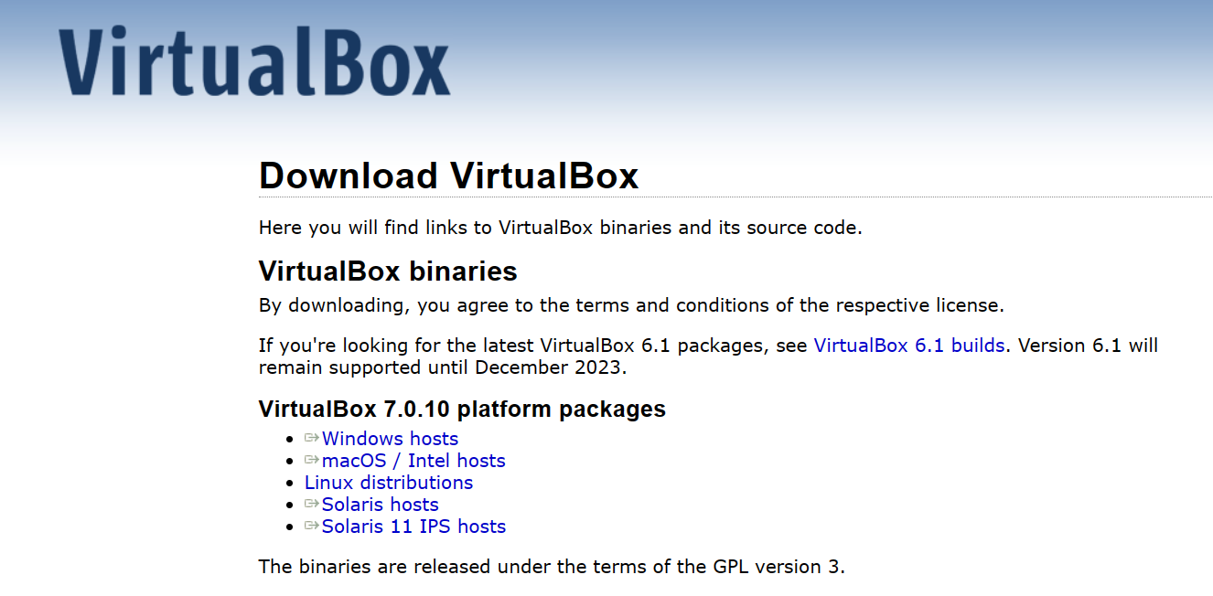

Click on Windows / macOS depending upon machine that you are using.

* Once the download is complete, Open the file and give it access to make changes in your pc .After that This window will appear.

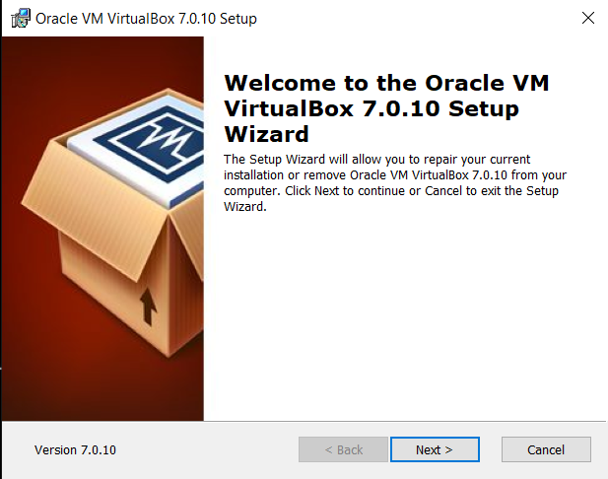

* After that this window will appear. Change location of your file by clicking Browse. Otherwise Just click Next.

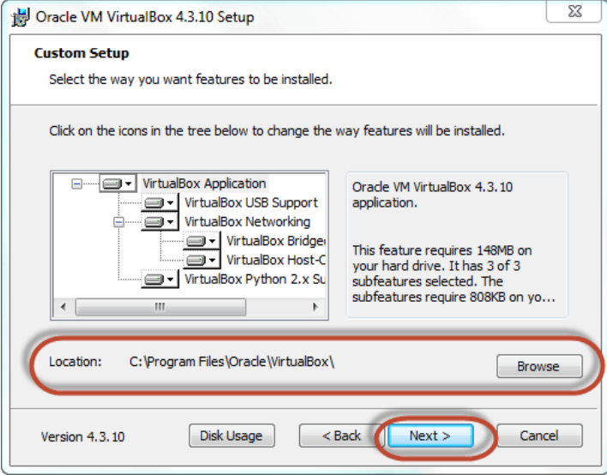

* After that This Window will appear. Just Click Yes

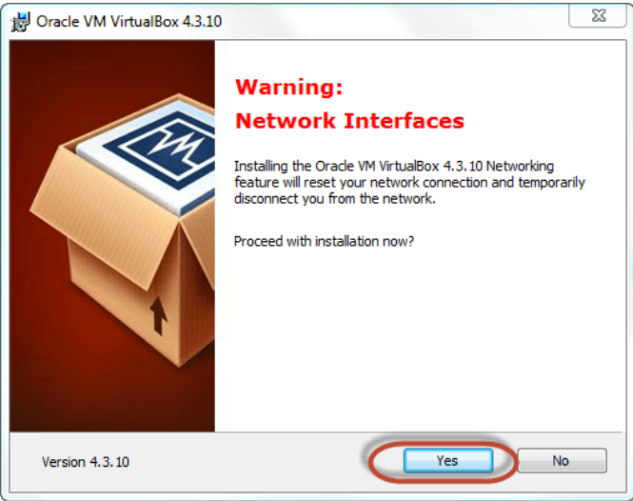

* Now Click Install to Begin Installation.

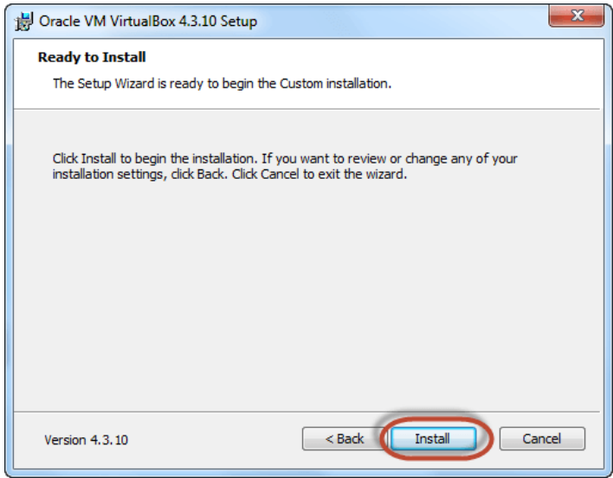

* Now Click Finish. You Virtual Machine has been installed

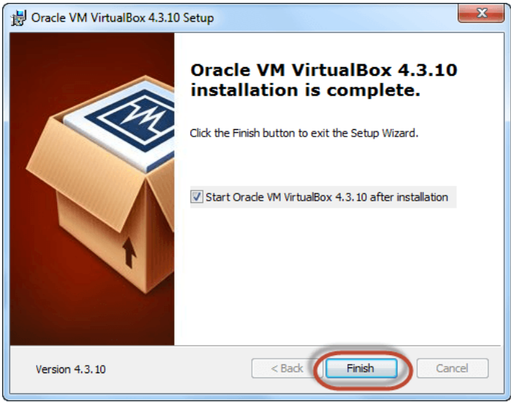

* This is virtual Machine‘s user Interface.

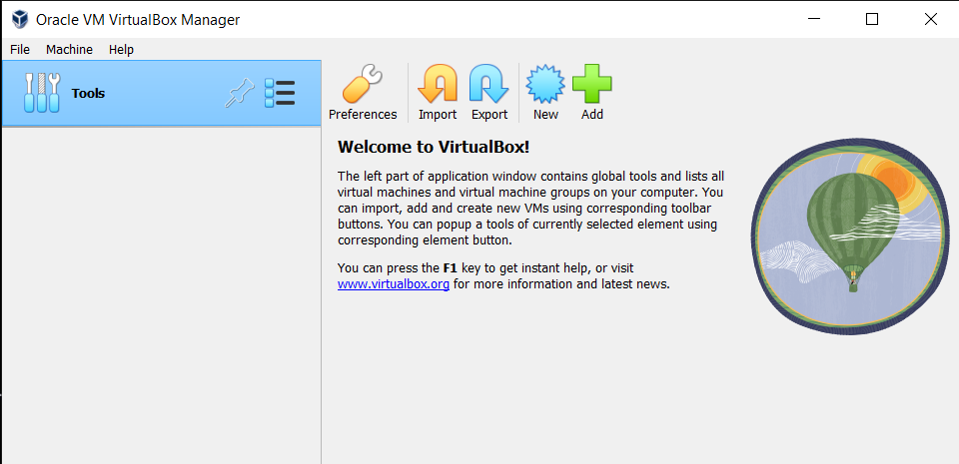

* Now click New.

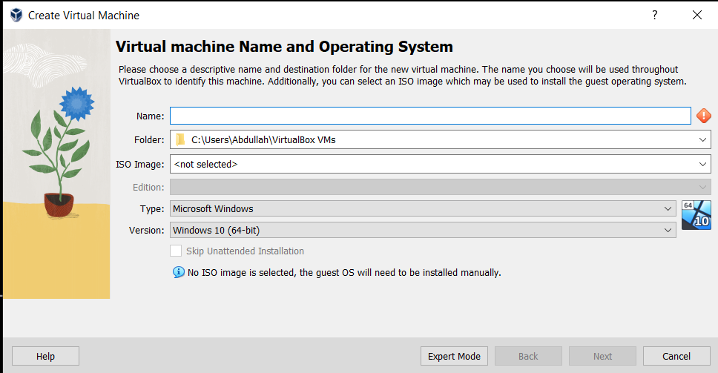

* Fill it with the name of Virtual Machine and click Next.

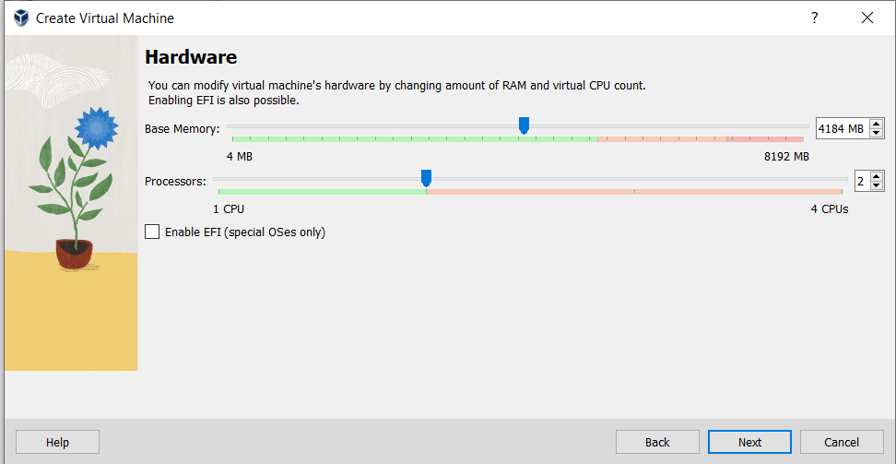

* Now assign base memory and processors. Then Click Next.

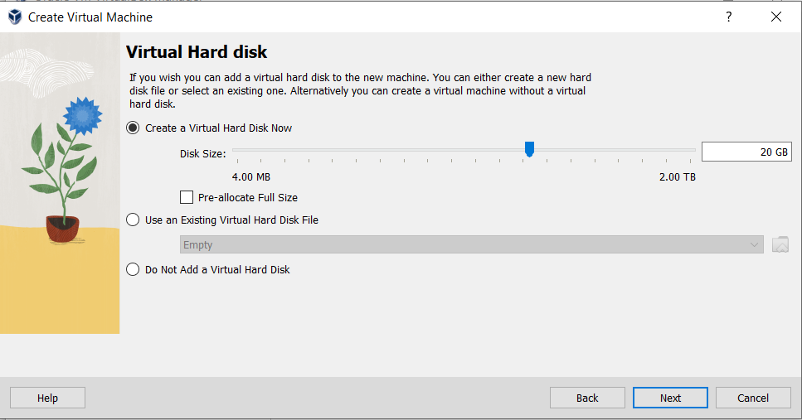

* Allot disk size and click next

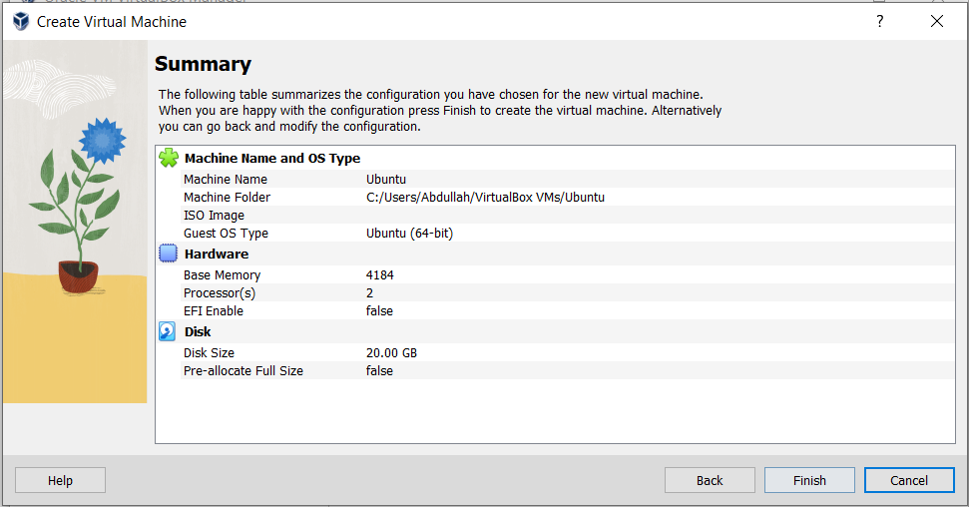

* Click Next and Following Window will appear.

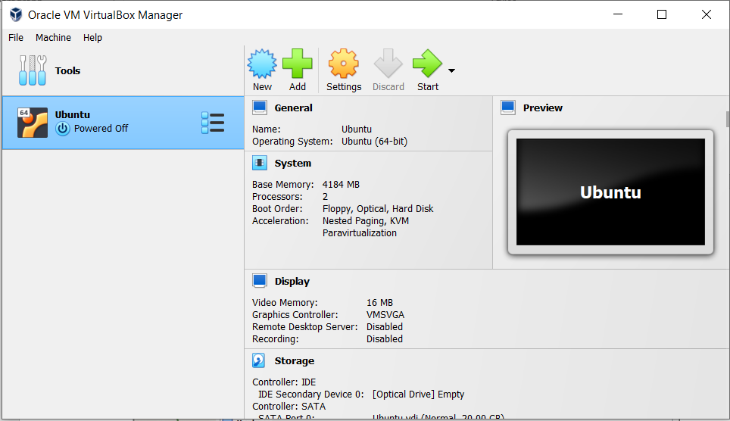

* Click on Setting and then go to storage.

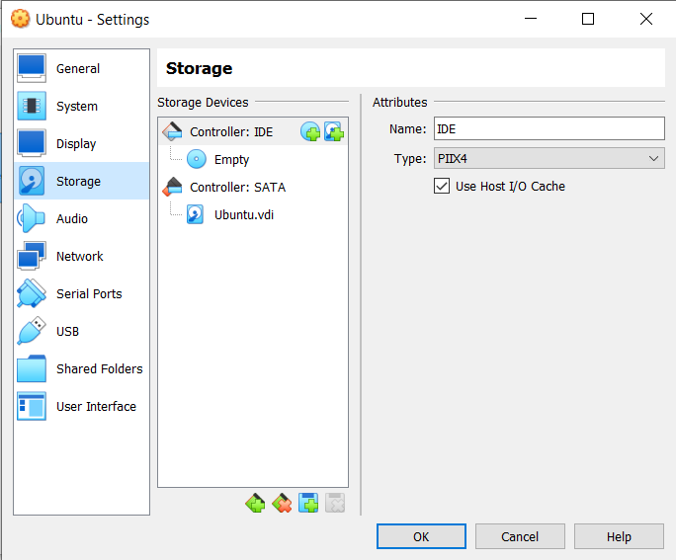

* Now click Empty under Controller: IDE and choose where Ubuntu is installed and click open. Following window will appear

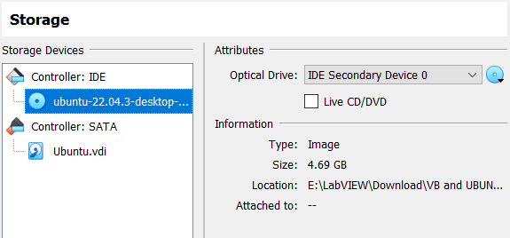

* Now click Ok to proceed. This window will appear.

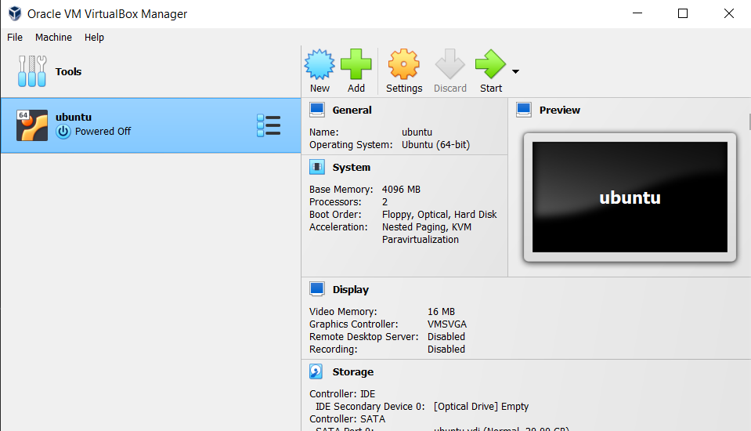

* Now click Start.

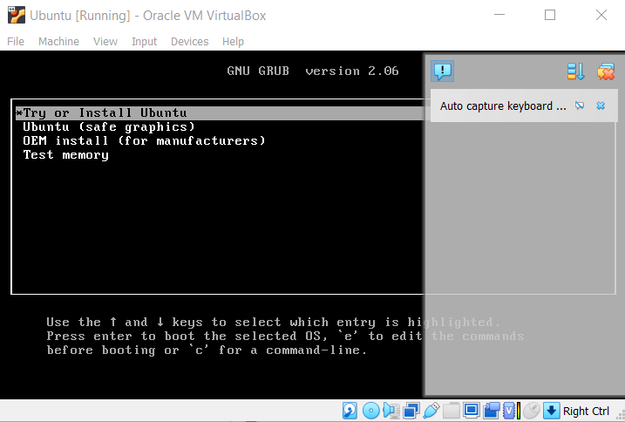

* Now Click Enter.

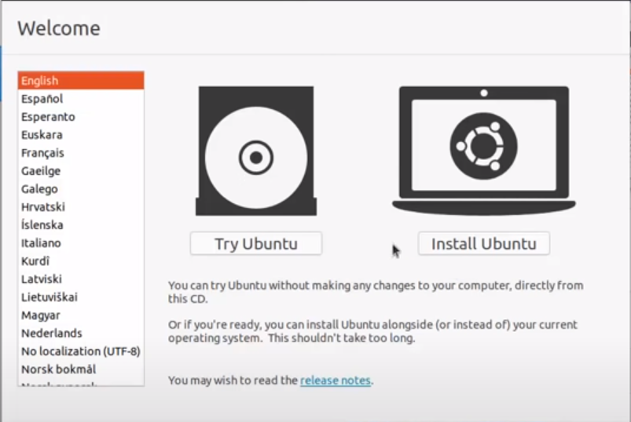

* Click Install Ubuntu

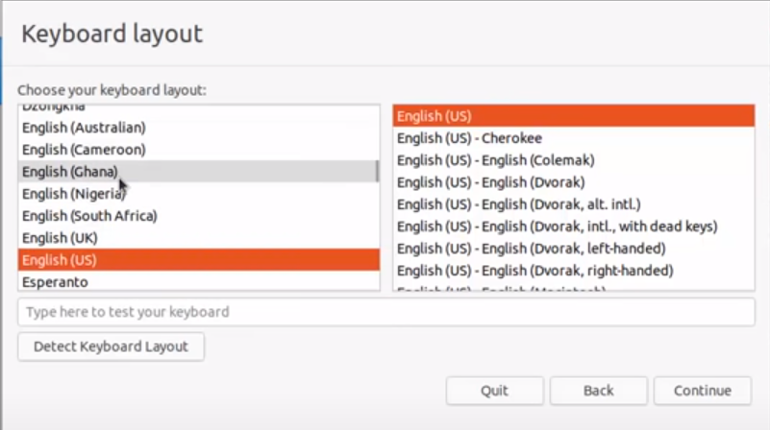

* Click Continue.

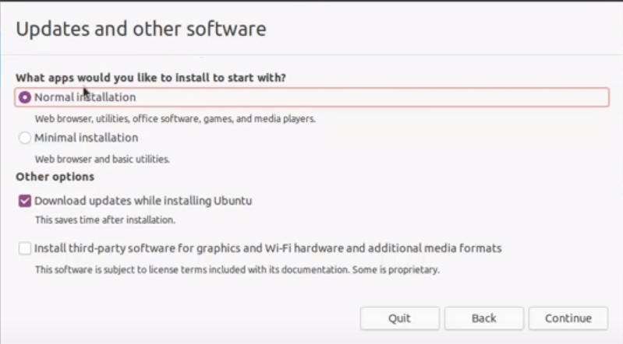

* Mark Last Option as Tick and Click Continue.

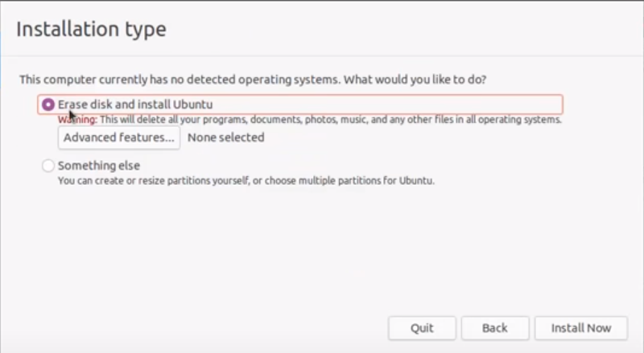

* Leave everything as it is and click Install now.

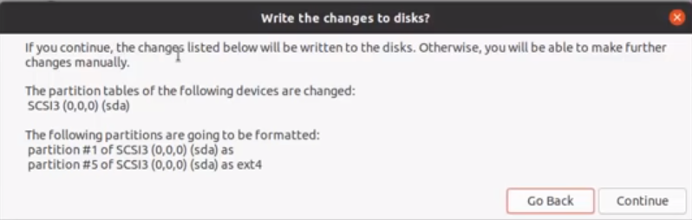

* This pop-up appears, just click Continue.

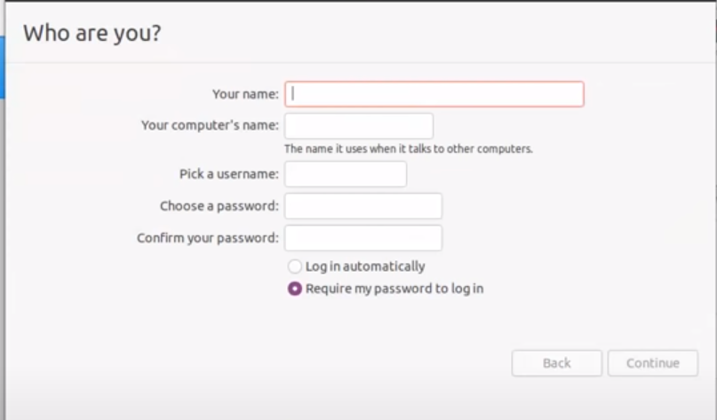

* Fil the form with relevant info and click Log in auto matically so that you can automatically log into your computer. Then click Continue.

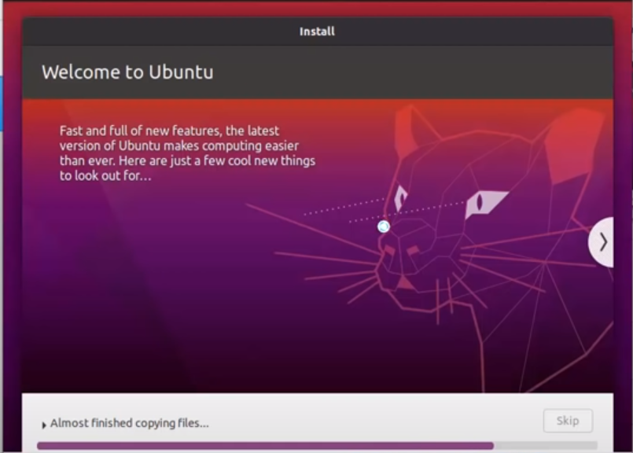

* Just wait your software is being installed.

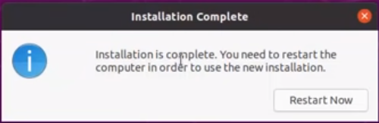

* This pop up appears. Just click Restart now.
* After restarting your PC log in to virtual machine. When opening Ubuntu following screen will appear.
* 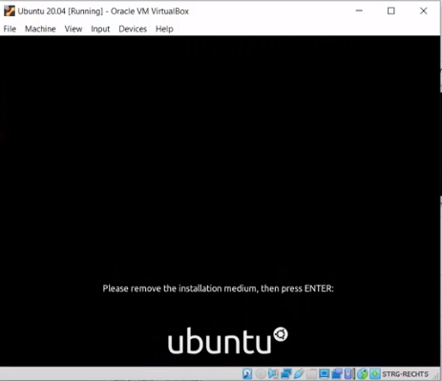Press Enter and you will log in to your OS

1: Linux Command Line:

Example :

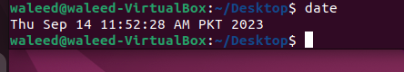

2: Command Syntax:

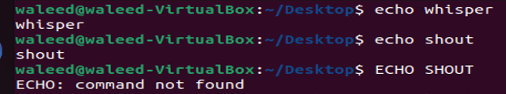

3:Displaying Files’Contents with Cat:

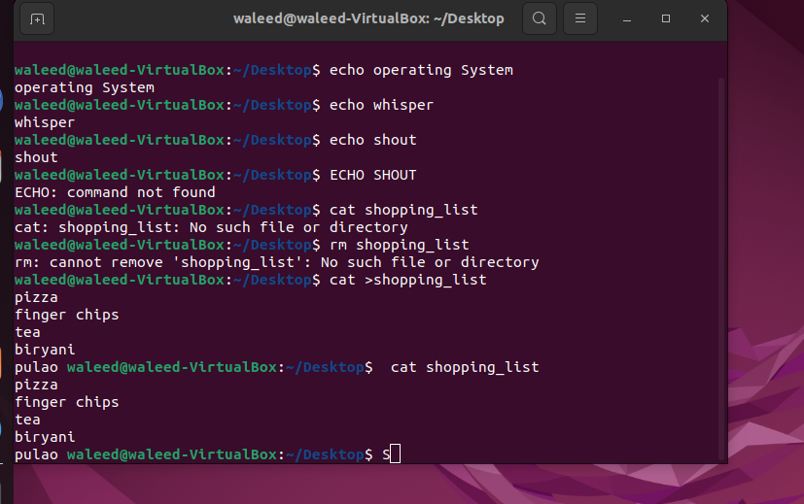

4 :Deleting Files With rm:



5 :Copying And Renaming Files With cp and mv:

